**APPLIED STATITICS LAB**

**WEEK-2**

NAME: SRIJITH U

REG NO : 22BCE8916

If Else

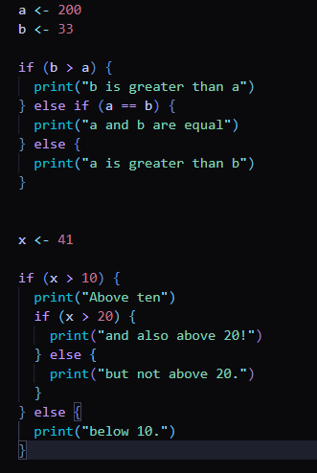

Output:

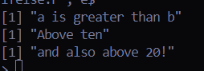

1)Write a programme for given number is prime or not?

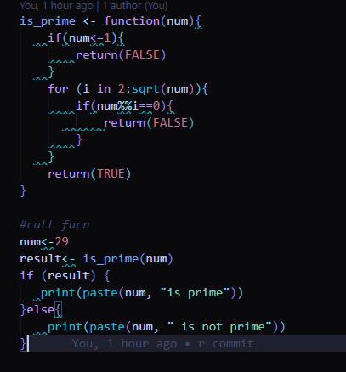

Output:



2) Calculate n! using ‘R’

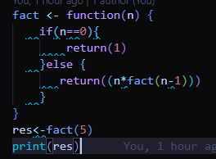

Output:



3)Find the programme for nCr using ‘R’

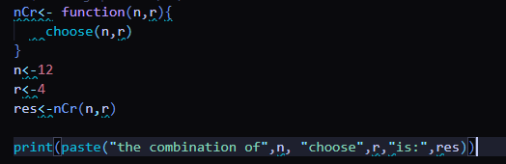

Output:



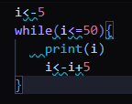While loop

Output:

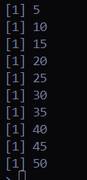

Multiplicative Tables

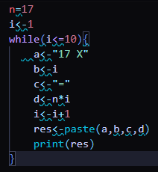

Output:

